Create a Database named School and perform all the DDL commands (CREATE, ALTER, DROP, RENAME, TRUNCATE) for the table named STUDENT with fields: Roll_No Name Marks Grade.

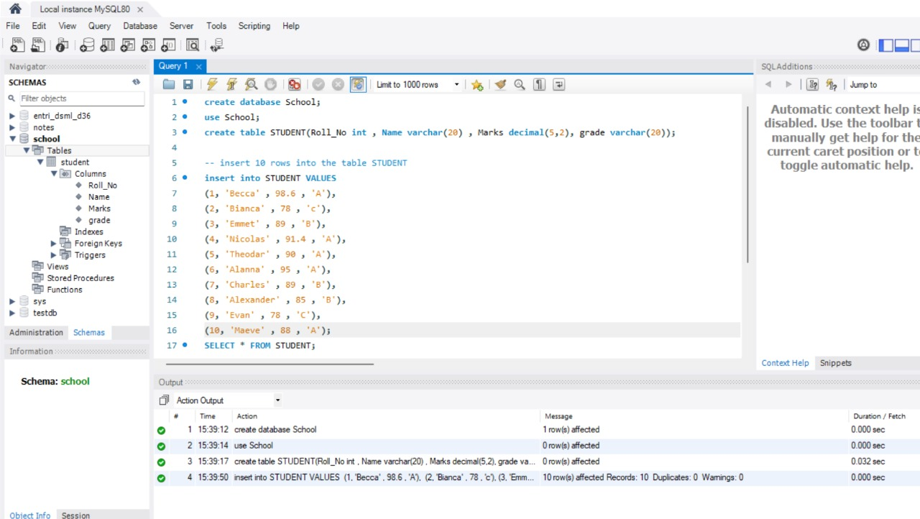

1)Use the select command to display the table.

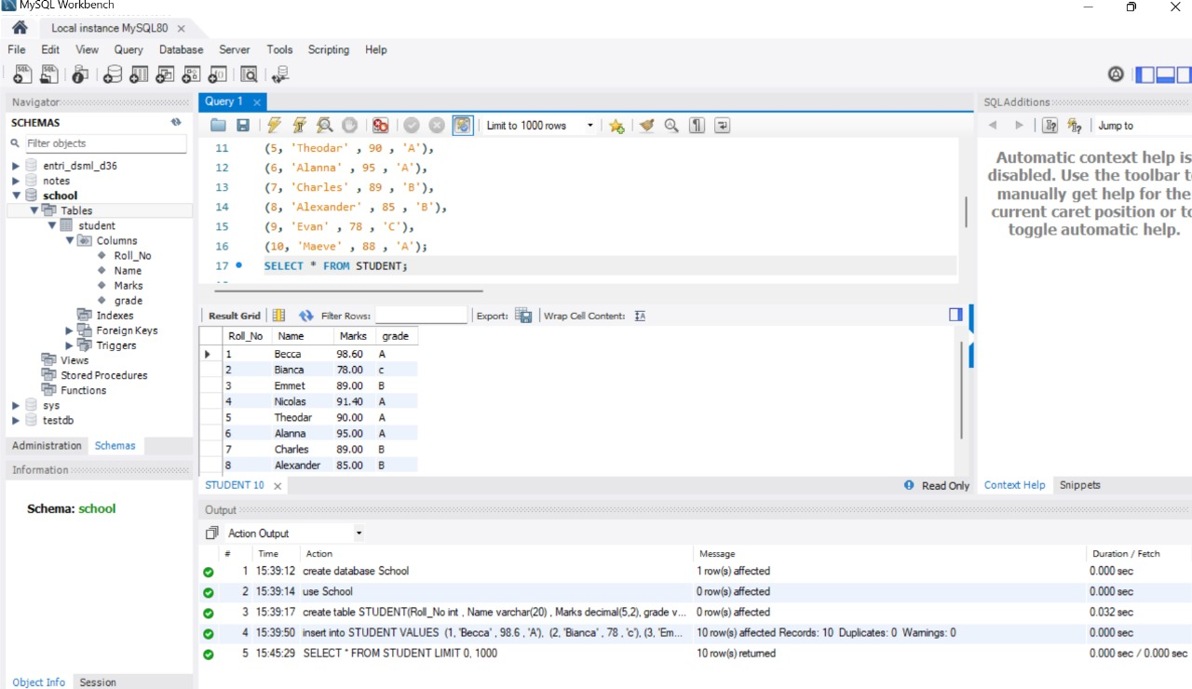

2) Add a column named Contact to the STUDENT table.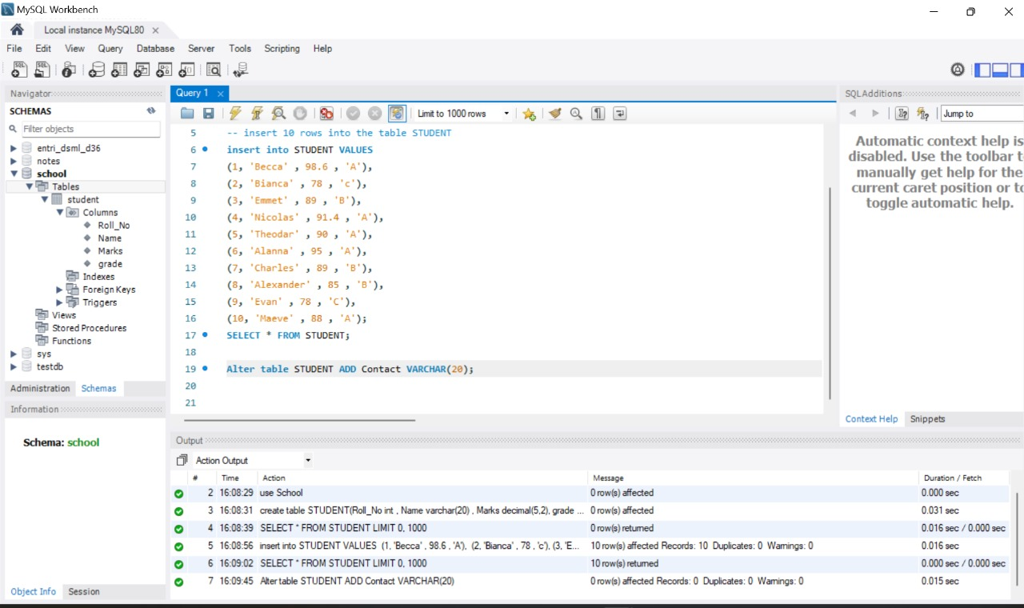

3) Remove the Grade column from the Student table

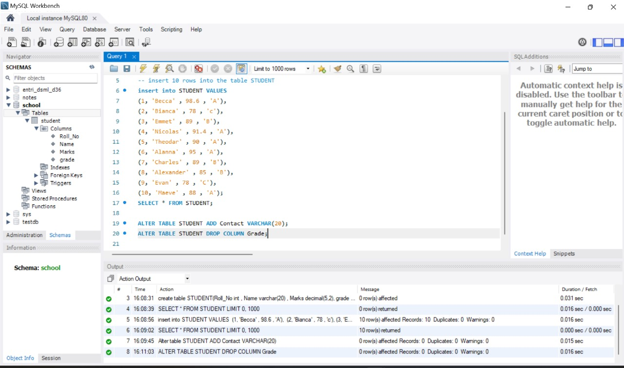

4) Rename the table to CLASSTEN. 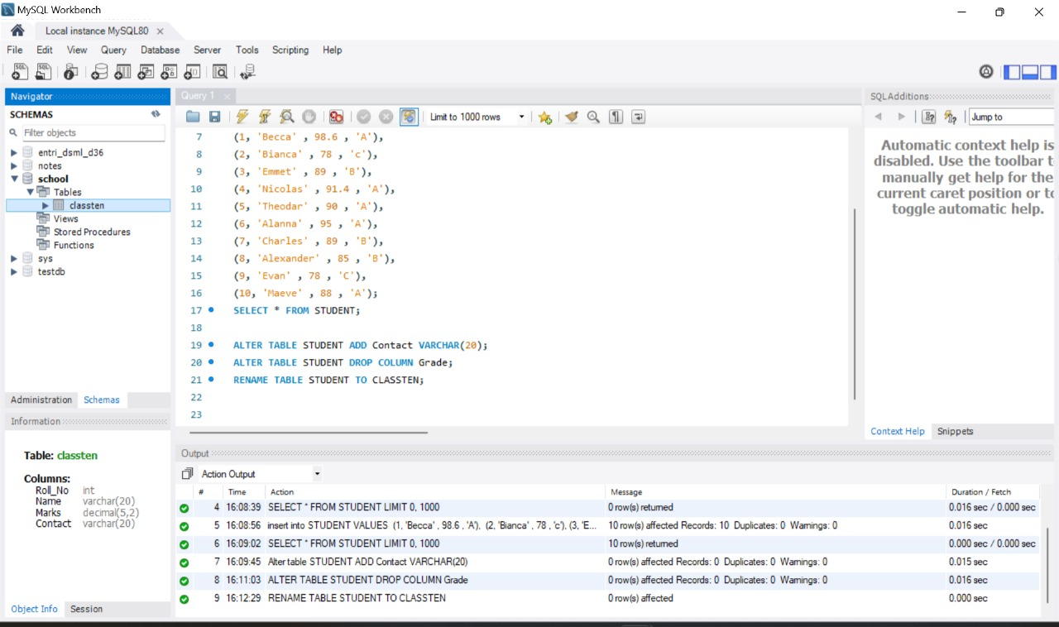

5) Delete all rows from the table.

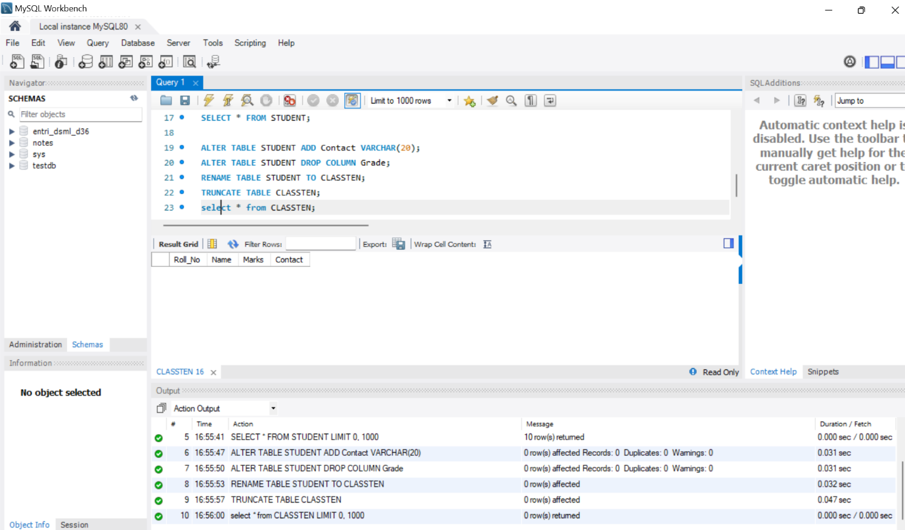

6)Remove the table from the database.